**Write a program to implement following operations on a linear array:**

1. **Read n elements and display**
2. **Insert a new element in the middle of an array.**
3. **Delete the first element of an array.**
4. **Find the location of a last element.**

**Student Name: Prince Kumar UID: 20BCS3936**

**Branch: CSE Big Data Section/Group: BD2/A**

**Semester: 03 Date of Performance: 16/08/2021**

**Subject Name: Data Structures Lab Subject Code:** **20CSP-236**

**1. Aim/Overview of the practical:** ToDevelop Program to implement Array Data Structures.

**2. Task to be done:**

* Create an array.
* Read the values in array.
* Insert elements at the specified positions.
* Delete element at the designated index.
* Search a number in array to find its location.

**3. Flowchart:**

While

Choice != 6

**N Y**

**Y**

Create an array

Choice = 1

Choice = 2

**Y**

Display array

**Y**

Insert elements

Choice = 3

**Y**

Delete elements

Choice = 4

Search elelments

Choice = 5

**Y**

**4.Program Code:**

#*include* <stdlib.h>

#*include* <stdio.h>

int a[20];

int n, val, i, j, pos;

void *create*() //*creating an array*

{

*printf*("\nEnter the size of the array elements:\t");

*scanf*("%d", &n);

*printf*("\nEnter the elements for the array:\n");

*for* (i = 0; i < n; i++)

    {

*scanf*("%d", &a[i]);

    }

} //*end of create()*

void *display*() //*displaying an array elements*

{

    int i;

*printf*("\nThe array elements are:\n");

*for* (i = 0; i < n; i++)

    {

*printf*("%d\t", a[i]);

    }

} //*end of display()*

void *insert*() //*inserting an element in to an array*

{

*printf*("\nEnter the position for the new element:\t");

*scanf*("%d", &pos);

*printf*("\nEnter the element to be inserted :\t");

*scanf*("%d", &val);

*for* (i = n - 1; i >= pos; i--)

    {

        a[i + 1] = a[i];

    }

    a[pos] = val;

    n = n + 1;

} //*end of insert()*

void *del*() //*deleting an array element*

{

*printf*("\nEnter the position of the element to be deleted:\t");

*scanf*("%d", &pos);

    val = a[pos];

*for* (i = pos; i < n - 1; i++)

    {

        a[i] = a[i + 1];

    }

    n = n - 1;

*printf*("\nThe deleted element is =%d", val);

} //*end of delete()*

void *search*()

{

    int num, flag = 0;

*printf*("Enter the number to find the location: ");

*scanf*("%d", &num);

*for* (int i = 0; i < 20; i++)

    {

*if* (num == a[i])

        {

            flag = 1;

*break*;

        }

    }

*if* (flag == 1)

*printf*("%d is present at %d in array", num, i);

*else*

*printf*("%d do not belong to array", num);

}

int *main*()

{

    int choice;

*do*

    {

*printf*("\n\n--Menu--\n");

*printf*("1.Create\n");

*printf*("2.Display\n");

*printf*("3.Insert\n");

*printf*("4.Delete\n");

*printf*("5.Search\n");

*printf*("6.Exit\n");

*printf*("-----");

*printf*("\nEnter your choice:\t");

*scanf*("%d", &choice);

*switch* (choice)

        {

*case* 1:

*create*();

*break*;

*case* 2:

*display*();

*break*;

*case* 3:

*insert*();

*break*;

*case* 4:

*del*();

*break*;

*case* 5:

*search*();

*break*;

*case* 6:

*exit*(0);

*break*;

*default*:

*printf*("\nInvalid choice:\n");

*break*;

        }

    } *while* (choice != 6);

*return* 0;

}

1. **Output: Image of sample output to be attached here**

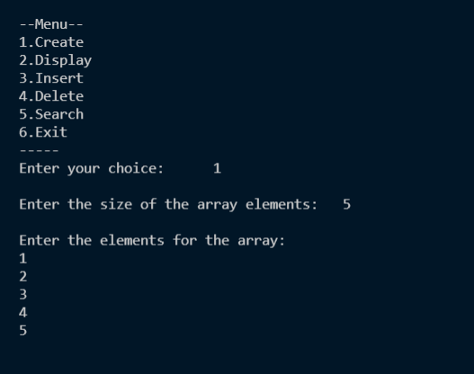

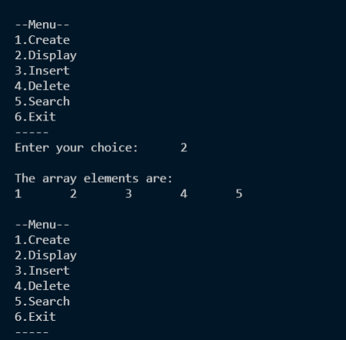

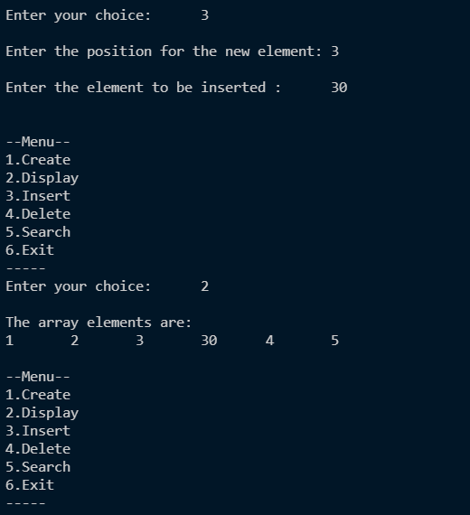

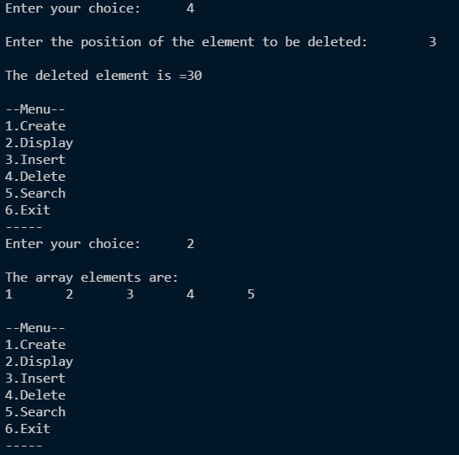

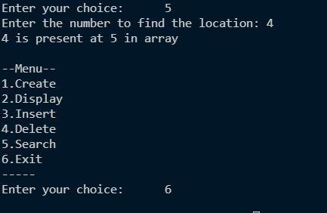

**Learning outcomes (What I have learnt):**

1. **To implement and perform various operations on linear data structures.**

**2. To use Linear array effectively in programming.**

**3. To delete and insert elements in the middle of the array.**

**Evaluation Grid (To be created as per the SOP and Assessment guidelines by the faculty):**

|  |  |  |  |
| --- | --- | --- | --- |
| Sr. No. | Parameters | Marks Obtained | Maximum Marks |
| 1. |  |  |  |
| 2. |  |  |  |
| 3. |  |  |  |
|  |  |  |  |